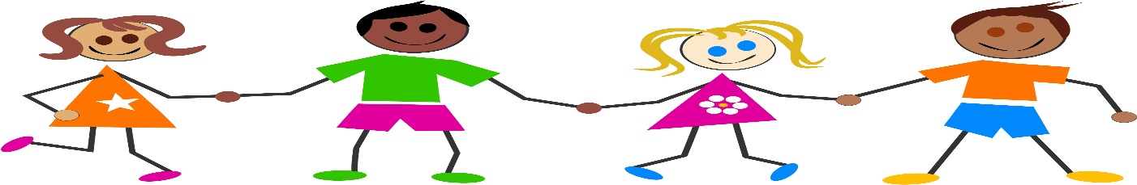

MAY
2015
Therakids
Addressing the Needs of Educators and Planting the Seeds of Classroom Wellness.
www.therakids.org

Summer Activities
Summer Activities
Upper Body Strength
Play toss and catch games in a kneeling position
Reading, writing, coloring, etc while on the tummy
Animal walking – snake crawling, bear, crab walk
Wheelbarrow walking
Tug of war

Self Help Skills

- Play dress up
- Undressing is easier than dressing so work on undressing skills first
- Practice putting things through slots like money with a piggy bank.
- Lacing cards and stringing beads build the foundation for pushing/pulling needed for buttoning
- Practice zipping/unzipping attached zippers first like those on backpacks, pants, purses.

Bilateral Coordination
- Blow bubbles and reach with both hands to pop them
- Tear strips of paper, and glue on paper to make a picture
- Play zoom ball
- Pull apart construction toys (legos or linking cubes)
- Jump rope
- Bounce a large ball using both hands
- Trace using stencils
- String beads to make jewelry

Handwriting
- Make raised letters on index cards to trace with fingers (use puffy paint, add food coloring to white glue).
- Write letters with a vibrating pen
- Form letters in play-doh, paint, sand, sugar, etc
- Write letters in the air using your pointer finger
Sensory Processing
- Ideas to calm - gentle slow rocking in a chair or swing, squeeze a foam ball, clay, play doh, etc. Heavy work for the body – wear a heavy backpack or carry a box filled with books, toys. Make a quiet corner
- Idea to increase level of alertness – fast rocking or swinging. Jumping on a mini trampoline or bouncing on a large therapy ball, playing on playground equipment, music with a fast beat.
Gross Motor
- Jumping jacks
- Balloon tennis
- Dancing
- Kickball
- Blow bubbles
- Jump rope
- Hula hoops

