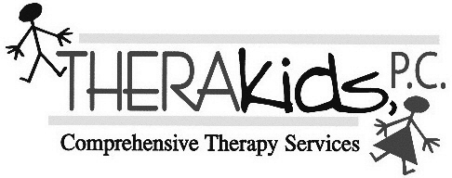

Physical Therapy Parent Treatment Note
__________________________________________________________________________________________

Date: Students:

The following skills were worked on today during physical therapy:

GROSS MOTOR SKILLS
Jumping up/down Jumping forward Up/down stairs
Jumping off a stool with two foot take off and landing.
Hopping on one foot
Other____________________________________________________

BALANCE
Walking on line/balance beam Standing on one foot
½ kneeling /dynamic activity Tall kneeling / dynamic activity
Other____________________________________________________

TRANSFERS
Mat to wheelchair Sitting to ½ kneel ½ kneel to stand
- Other___________________________________________________

STRETCHING, STRENGTHENING AND COORDINATION
Lower extremity flexibility exercises Core strengthening exercises
Riding tricycle Jumping jacks Galloping Skipping
Catching/throwing a ball Kicking a ball Jumping sideways back/forth over a line
Throwing a ball overhand at a target Throwing a ball underhand at a target
Other______________________________________________________

Comments:
________________________________________________________________________________________________________________________________________________________________________________________________________________________________________________________________________________________________________________________________________________________________________

Feel free to contact me if you have any questions.

