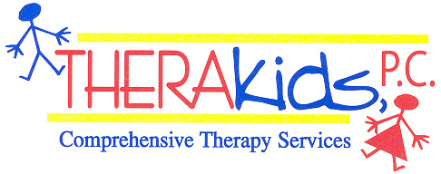

SUMMER ACTIVITIES FOR GROSS MOTOR SKILLS

- Balance Beam: Anytime you are on a playground, parking lot or anywhere that has railroad ties have your child practice walking on them foot over foot forward and also sidestepping along the beam.

- Hop Scotch: You can make this on a sidewalk with chalk or with masking tape and if the child has difficulty with hopping on one foot, start out with going feet together then apart and advance to one and two foot hops.

- Jump Rope: You can begin jump rope skills by placing the rope on the ground and having them jump over it. Then two people could hold it and gradually raise it and have the child jump over it. You can have the child hold the rope with you on the other end and wiggle the rope like a snake as well as having them turn it in circles. You can also make shapes with the rope on the ground and have the child walk along it for balance.

- Ball Skills: For children who are just learning to catch a ball, you can use a small beach ball and don’t blow it up all the way so it is easier to catch. This allows the child to catch successfully and if they miss the ball it doesn’t hurt when it hits them. You can also use this beach ball with a fat bat or a small racket to learn to hit a ball thrown to them. A beach ball travels slower than other balls and is easier to hit.

- Playground: Take your child to the playground or outside on your own playground as much as you can. If they are fearful of the steps and slides at first go up behind them and assure them you are right there. Try to get them to practice the steps and as soon as they can begin to go up the steps reciprocally. Encourage the use of the rail and walking up the steps rather than crawling up them.

- Running Games: You can work on balance on uneven surfaces by running in the grass; up and down hills; on different types of surfaces such as wood chips, taller grass etc. You can play games like red light/green light to encourage balance with stopping and starting and changing directions.

Encourage your child to play outside as much as possible and let them have fun. They will advance considerably with their gross motor skills just by exploring the outdoors.

If you have any questions feel free to contact me.

Therapist Name And Email

