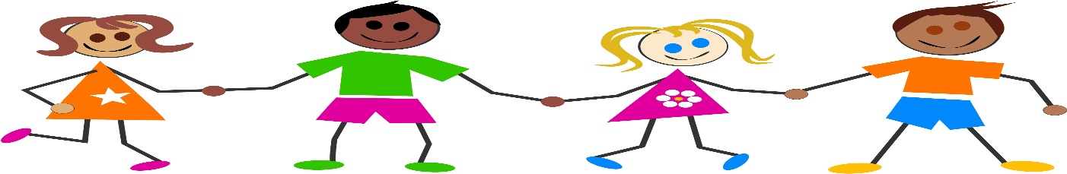
December 2017
TheraKids
Addressing the Needs of Educators and Planting the Seeds of Classroom Wellness.
Fine and Gross Motor Milestones
4-5 years

Cut along straight lines
Start to use 1 hand consistently
Start to cut along a curved line
Start to color inside the lines
Copy a square
Begin learning to print capital letters

Fine Motor

3-4 years

Fold paper in half
Build a tower with small blocks
Copy a cross
Cut across a piece of paper
Draw a circle independently
Feed self with a fork and spoon
years

Cuts out simple shapes
Colors within lines
Pastes and glues appropriately
Can draw basic pictures
Uses a 3 fingered grasp of pencil
Printing first and last name

Gross Motor

3 years
- Imitates standing on 1 foot
- Climbs jungle gym and ladders
- Walks up/down stairs alternating feet
- Catches using body

4-5 years

- Kicks a ball
- Able to walk on a line
- Throws a ball overhead
- Able to hop on 1 foot
- Able to walk upstairs while holding an object
- Catches a small ball using hands only

5-6 years

- Skips forward after demonstration
- Can jump over an object and land on both feet
- Can walk along a line
- Can run around obstacles
Therakids p.c. provides specialized occupational, physical and speech therapy services to help children overcome developmental concerns. Services are provided in the school setting throughout southwestern Illinois by licensed occupational therapists, occupational therapy assistants, physical therapists, physical therapists assistants and speech-language pathologists. Website: www.therakids.org

